**__**

Function description

**Functional Design Specification Central Wind Farm Controller**

Contents

1 General 6

1.1 Scope of document 6

1.2 Scope of design 6

1.3 Conventions of the sign of active and reactive power 6

2 System Architecture 7

2.1 Wind Farm General overview 7

2.2 Central Wind Farm Controller Architecture. 8

2.3 Active Power Control 9

2.4 Reactive Power Control Modes 10

2.4.1 Voltage Control Mode sub mode 1 10

2.4.2 Voltage Control mode submode 2 13

2.4.3 Reactive Power Control Mode 15

2.4.4 Powerfactor Control Mode 16

3 Hardware setup 17

3.1 19” Swing frame rack for RTU 560 17

3.2 Communication units 17

3.3 Power supply unit 18

3.4 Component overview 19

4 Functionality 20

4.1 Setting the Setpoint Procedure 20

4.2 Reactive Power Control Mode Selection 20

4.3 PPA access 20

4.4 Local/Remote 20

4.5 Communication with LWFC is down. 20

4.6 Shutting down the LWFC 20

5 HMI 21

6 References 22

7 Tabel of Figures 23

**Abbreviations**

A Ampere

CU Copper

CWFC Central Wind Farm Controller

GIS Gas Insulated Switchgear

HMI Human Machine Interface

IED Intelligent Electronic Device

kV Kilo Volt

kA Kilo Ampère

LWFC Local Wind Farm Controller

MV Medium Voltage

N/A Not Applicable

P&C Protection and Control

PCC Point of Common Coupling

SA Substation Automation

SAT Site Acceptance Test

SCADA Supervisory Control and Data Acquisition

V Volt

WEC Wind Energy Converter

WTG Wind Turbine Generator

**Related documents**

|  |  |
| --- | --- |
| **Document number** | **Title** |
| SOC_11-175 | D4-Wind_Farm_Connection_Requirements_5_9 |
| 180507 | F1-WPZ Functional Requirements Wind Farm Controller 1.0 |
| 081116 | D5-Compliance Wind Farms V 4.2 Clean |
| 181116 | D6-Data Exchange Wind Farms V 5.3 |
| 180513 | F2-WPZ Functional Scheme power management 1.0 |
| E0014032-E03-FP1-000002 | I/O list CWFC |

**Revisions**

|  |  |  |  |
| --- | --- | --- | --- |
| Rev. Ind. | Page (P)  Chapter (C) | Description | Date Dept.-Init. |
| A | All | First issue | 11-03-2020/KSc |

**Approval**

|  |  |  |  |
| --- | --- | --- | --- |
| Approved by | Role | Date | Visa |
| Eric Niekerk | Project manager | 10-03-2020 |  |
| Ugur Cicek | Project Engineer | 10-03-2020 |  |
| Karsten Schoenmaker | Author | 10-03-2020 |  |

**Distribution**

|  |  |  |  |  |
| --- | --- | --- | --- | --- |
| Company | Department | Person | Date | Copy |
| Vogelweg HV station B.V. |  |  |  | 1 |
| ABB Power Grids The Netherlands B.V. | PGGA | Eric Niekerk | 10-03-2020 | 1 |
|  |  | Karsten Schoenmaker | 10-03-2020 | 1 |
|  |  | Document control | 10-03-2020 | 1 |

|  |  |  |  |
| --- | --- | --- | --- |
| Vogelweg HV station B.V. |  |  |  |
| Visit Address | Landauer 2 | 3897 AB | Zeewolde |
| Postal Address |  |  |  |
|  |  |  |  |
| ABB Power Grids The Netherlands B.V. |  |  |  |
| Visit Address | George Hintzenweg 81 | 3068 AX | Rotterdam |
| Postal Address | P.O. Box 301 | 3000 AH | Rotterdam |
|  |  |  |  |

**Introduction**

This Functional Design Specification describes the soft- and hardware configuration of the Central Wind Farm Controller (CWFC) intended for Wind Farm Zeewolde. The purpose of the CWFC is to ensure grid compliance by coordinating the efforts of six Local Wind Farm Controllers (LWFC) by acting as a master controller. The main function will be controlling the active & reactive power at the Point of Common Coupling (PCC). The CWFC will also function as a gateway in providing information from the LWFC’s to the Substation SCADA system.

# General

## Scope of document

The main function of this design specification is to provide a clear view, how we envision the central wind farm controller as part of the wind farm.

This document will serve as a continued working- and discussion basis for the actual realization of the CWFC.

## Scope of design

The central wind farm controller will be in charge of maintaining grid compliance. To achieve grid compliance the Windfarm must comply with the TSO regulations as specified in SOC 11-175. The PCC will be the reference point for determining Grid Compliance.

To achieve Grid Compliance the CWFC will be able to regulate the active and reactive power provided by the WTG’s. The CWFC will also be able to coordinate the efforts of multiple LWFC’s in order to manage the active and reactive power. Design will be according to requirement 448 [1].

## Conventions of the sign of active and reactive power

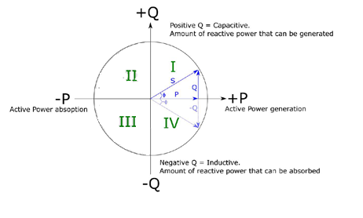

Figure Power Sign Convention

# System Architecture

## Wind Farm General overview

The CWFC will communicate with all involved parties over the IEC60870-5-104, as shown in the overview below.



Figure System Architecture Overview

The PPA will access the WTG SCADA directly with regards to monitoring data and performing curtailment. As discussed on 8-1-2020. Proposed by Outsmart.

Tennet B.V. will no longer connect directly to the CWFC. Outsmart will communicate with Tennet directly via phone, when this is necessary. The CWFC will be configured in a way that minimal adjustments are needed in case Tennet will be connected to the CWFC directly according to [3]. As discussed on 21-1-2020.

## Central Wind Farm Controller Architecture.

This paragraph shows the general architecture of the Central Wind Farm Controller.

The systems connected to the CWFC are the LWFC and the System Operator.

The TSO will not be connected but preparations have to be made for the TSO to be able to pass on setpoint requests, send/receive data routed through the gateway function.

The System Operator will have the ability to pass on setpoint requests, select new Control modes and send/receive data routed through the gateway function.

The Local Wind Farm Controllers will receive setpoints from the CWFC and provide information regarding the available P & Q.



Figure CWFC Architecture Layout

* Setpoint selection
* Reactive Power Control Mode Selection
* Power Divider
* Data concentrator / Gateway LWFC->CWFC

## Active Power Control

Active Power Control will regulate the active power from the WEC’s to the Grid. Generally the maximum available power will be used as setpoint. It will also be possible to enter a setpoint. Also called “Absolute Production Constraint”. As requested in [2] subsubparagraph 4.2.2.2

The P divider will dynamically calculate the setpoints for the LWFC.



Figure Diagram active Power Control

If P at the PCC is equal to the “P setpoint” or “P max” then the P total measured (LWFC’s) should be equal to “P setpoint” or “P max” respectively. This applies when the system is in a settled state.

The local wind farm controller will divide the supplied setpoint into setpoints to the WEC units. The WEC unit setpoint must be calculated in a way that it will compensate for the “Line Losses” and “Phase Rotation” caused by the cables in order to be able to match the values measured by the LWFC to the received setpoint.

Setpoint Ramp & Gradient constraint will be handled via the LWFC.

## Reactive Power Control Modes

The CWFC will have three control modes for regulating the reactive power at the Grid Connection Point. As requested in [2] subsubparagraph 4.2.2.1

* Voltage Control Mode (sub mode 1 & 2)
* Power Factor Control
* Reactive Power Control

The next paragraphs will give an overview how the reactive power control modes will be implemented.

### Voltage Control Mode sub mode 1

Voltage control (U-control), characterized by Voltage Droop, Set Point Voltage, with additional functionality to periodically check and if necessary adjust locally the Set Point Voltage to bring the Reactive Power Exchange at the PCC to the Reference Steady State Reactive Power Exchange.

During normal operation of Voltage Control Mode sub mode 1 the system will measure the voltage at the PCC and compare this with the U setpoint. If the value deviates, reactive power exchange will be increased or decreased according to the voltage droop settings.

While the Voltage control mode is active there will be periodic checks if the Voltage and Reactive Power at PCC exceed dynamic threshold or disturbance threshold.

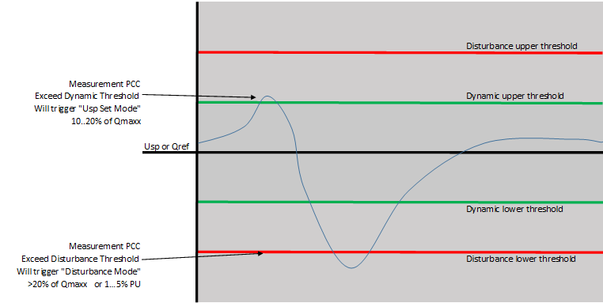

Figure Chart stating ΔQ or ΔU over time

Exceeding the “Dynamic Upper/lower Threshold will trigger the “Usetpoint set” mode and it will set Usetpoint to match the Upcc at the point where Qpcc = Qref.

The CWFC will have the ability to determine locally the Set Point Voltage based on the Agreed Steady State Reactive Power Exchange at the PCC indicated by the Reference Steady State Reactive Power Exchange. The CWFC must have the ability to process the Reference Steady State Reactive Power Exchange indicated by the Network Operator.

When the Disturbance threshold is surpassed the system will go into disturbance mode. During this mode the Reactive power will be held for 15minutes before returning to normal operations.

During a voltage drop/rise larger than the droop percentage the maximum Q available will be injected/absorbed.

If Q at the PCC is equal to the “Q ref” then the Qtotal measured by the LWFC should be equal to “Qoffset”. This applies when the system is in a settled state.

The local wind farm controller will divide the supplied setpoint into setpoints to the WEC units. The WEC unit setpoint must be calculated in a way that it will compensate for the “Line Losses” and “Phase Rotation” caused by the cables in order to be able to match the values measured by the LWFC to the received setpoint.

#### Block Diagram Voltage Droop Control Mode 1



Figure Block diagram voltage power control mode1

$$Qsetpoint LWFCx=\left( α*\left(\frac{Usetpoint-Upcc}{Usetpoint}\right)*Qmax+Qoffset \right) RX$$

The alpha coefficient represents the Droop percentage.

* 25 = 4%
* 18 = 5,6%
* 10 = 10%

The Q divider will use static ratio’s. RX is the factor that divides the calculated Q over the LWFC output.

The Overflow Detection and Redistribution Function will detect the event where a Qsetpoint will become bigger than the Q available per LWFC. The amount of Q unaccounted for will be redistributed over the other LWFC’s that still have an unaccounted amount of Q available.

### Voltage Control mode submode 2

Voltage control (U-control), characterized by Voltage Droop, Set Point Voltage

The CWFC must have the ability to process the Set Point Voltage indicated by the Network Operator. So it will periodically check if there is a new setpoint given.

The Voltage Control mode Sub mode 1 will measure the voltage at the PCC and compare this with the Voltage setpoint. If the value deviates, reactive power exchange will be increased or decreased according to the voltage droop settings.

There is no automatic “Setpoint Set Mode” or “Disturbance” mode.

During a voltage drop/rise larger than the droop percentage the maximum Q available will be injected/absorbed.

#### Block Diagram Voltage Droop Control Mode 2



Figure Block diagram voltage power control mode2

$$Qsetpoint LWFCx=\left( α*\left(\frac{Usetpoint-Upcc}{Usetpoint}\right)*Qmax+Qoffset \right) RX$$

The alpha coëfficient represents the Droop percentage.

* 25 = 4%
* 18 = 5,6%
* 10 = 10%

The Q divider will use static ratio’s. RX is the factor that divides the calculated Q over the LWFC output.

The Overflow Detection and Redistribution Function will detect the event where a Qsetpoint will become bigger than the Q available per LWFC. The amount of Q unaccounted for will be redistributed over the other LWFC’s that still have an unaccounted amount of Q available.

### Reactive Power Control Mode

This paragraph will provide an overview how the “Reactive Power Control Mode” is implemented in the CWFC. Beginning with this block diagram giving a schematic overview of the control mode.

The CWFC will measure the Reactive Power Q at the PCC. It will then be compared with the Q setpoint and corrective action will be taken by increasing or decreasing the reactive power per Local Wind Farm Controller.

#### Block Diagram Reactive Power Control Mode



Figure Block diagram reactive power control

### Powerfactor Control Mode

This paragraph will provide an overview how the “Power Factor Control Mode” is implemented in the CWFC. Beginning with this block diagram giving a schematic overview of the control mode.

First step will be to determine the PF at PCC then it will be compare to the PF setpoint. The difference will be added/subtracted from the total PF calculated from the LWFC measurements. From this value the new Reactive Power Q will be determined.

#### Block Diagram Power Factor Control Mode



Figure Block diagram power factor control

# Hardware setup

The hardware for the central wind farm controller will exist of a remote terminal unit of the type RTU560 that is fitted with PLC functionality. In this chapter we will elaborate on the proposed hardware.

## 19” Swing frame rack for RTU 560

The RTU560 modules will be places in a 19” Rack 560SFR02. The rack has sufficient slots available and gives the opportunity to expand the system in the future.

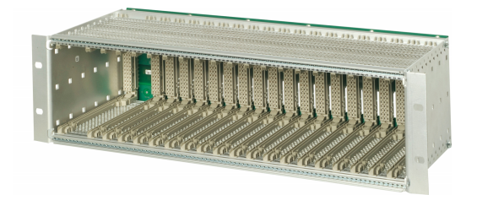

Figure 560SRF02 Swing rack frame

## Communication units

This RTU560 module of type 560CMR01 will be used for communication purposes. The ethernet connections will be setup via this unit. Two ethernet connection are available per unit. Four units are accounted for in this design.

One of the four units will also have the PLC License to run the CWFC application.

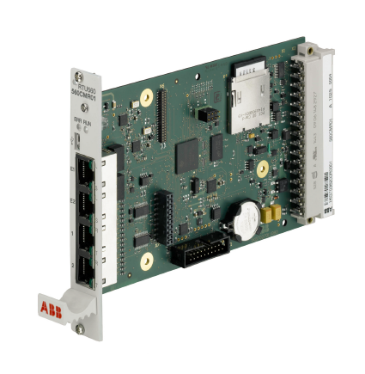

Figure 560CMR01 Communications card

## Power supply unit

This RTU560 module of type 560PSU02 will be used to power the RTU560.

The input range is 48 ... 220 V DC (-20%... +20%).

The output voltages are 5 and 48 VDC.

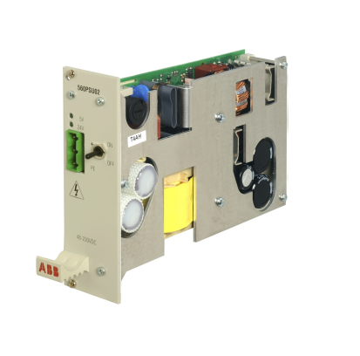

Figure 560PSU02 Power supply unit

## Component overview

|  |  |  |  |
| --- | --- | --- | --- |
| Item | Quantity | Part Number | Description |
| 1 | 1 | 560SFR02 R0001 | 19” Rack Frame (Swing) |
| 2 | 1 | 560BCU05R0001 | Bus Connection Unit |
| 3 | 4 | 560CMR01 R0001 | Communication Unit |
| 4 | 3 |  | Rel. 12 Basic license open DP, SD |
| 5 | 1 |  | Rel. 12 HMI/PLC/Archives license open DP, SD |
| 6 | 1 | 560PSU02 R0001 | Power Supply Unit |
| 7 | 15 | 560FPR01 R1002 | Blanc cover plate |
| 8 | 2 | 560BCU05R1002 | BCU connectors |

**Tabel 1 Component Overview**

# Functionality

## Setting the Setpoint Procedure

A setpoint is the level of system output which is desired. The regulator will steer the process output towards this value. The type of setpoint is determined by the type of “Reactive Power Control Mode”. The setpoint is entered via the CWFC “Configuration and Operation” menu.

When a new setpoint has been submitted, it will be checked for validity. When found to be valid, it will be implemented. Upon rejection, the user will be notified that the given setpoint is invalid.

|  |  |  |  |  |
| --- | --- | --- | --- | --- |
| **nr.** | **Reactive Power Control Mode** | **Input** | **Remarks** | **Disturbance mode\*** |
| 1 | Voltage Control submode 1 | Qref, Droop % | Automatic determinaton Uset = Upcc at  Qpcc == Qref | yes |
| 2 | Voltage Control submode V2 | Uset, Droop % |  | no |
| 3 | Power Factor Control | Cosine Phi |  | no |
| 4 | Reactive Power Control | Qset |  | no |
| * | Disturbance mode: CWFC will hold reactive power for 15min. | | |  |

**Tabel 2 Input Overview per Reactive power control mode**

## Reactive Power Control Mode Selection

It will be possible to select another “Reactive Power Control Mode” in the CWFC “Configuration and Operation” menu.

## PPA access

PPA’s will connect to the Enercon SCADA for monitoring data and Curtailment. They will no longer connect directly to the CWFC. As stated in req. 449 [1].

## Local/Remote

Local/Remote functionality is available with regards to changing setpoint or reactive power control modes.

## Communication with LWFC is down.

If the connection between CWFC and LWFC is lost. The standard course of action should be that het LWFC is stopped and the associated WEC units are stopped. Due to the fact that it is not possible to monitor/regulate the LWFC and associated WEC’s.

## Shutting down the LWFC

The CWFC will be able to generate a stop signal to all or some LWFC.

# HMI

Will be made available during the “Detail Design Phase”.

# References

|  |  |
| --- | --- |
| [1] | Windpark Zeewolde B.V., "Vraagspecificatie deel 1 Technische Eisen 1.2," 2018. |
| [2] | Windpark Zeewolde B.V., "Functional requirements Central Wind Farm Controller 1.0," 2018. |
| [3] | Tennet B.V., "Data Exchange Wind Farms 5.3," 2016. |

# Tabel of Figures

Figure 1 Power Sign Convention 6

Figure 2 System Architecture Overview 7

Figure 3 CWFC Architecture Layout 8

Figure 4 Diagram active Power Control 9

Figure 5 Chart stating ΔQ or ΔU over time 10

Figure 6 Block diagram voltage power control mode1 12

Figure 7 Block diagram voltage power control mode2 13

Figure 8 Block diagram reactive power control 15

Figure 9 Block diagram power factor control 16

Figure 10 560SRF02 Swing rack frame 17

Figure 11 560CMR01 Communications card 18

Figure 12 560PSU02 Power supply unit 18